CHAPTER: 9
SNAPSHOT OF WEBSITE

Admin Site

Employee Side

Admin Site

Admin login:

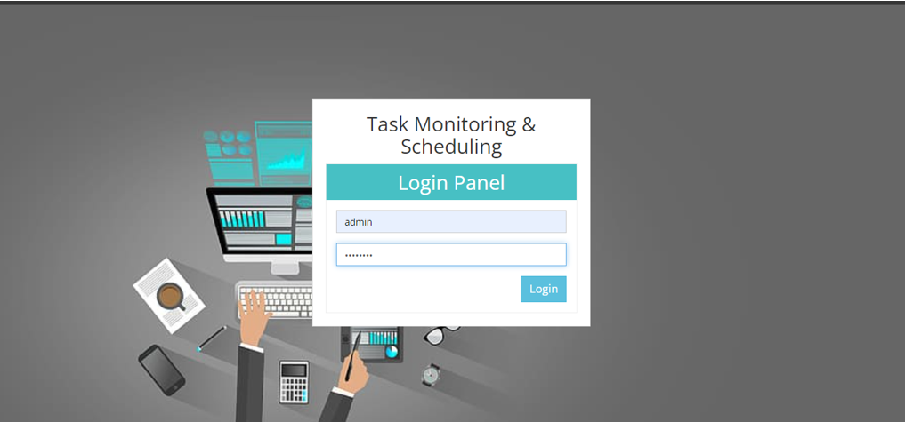

Dashboard:

